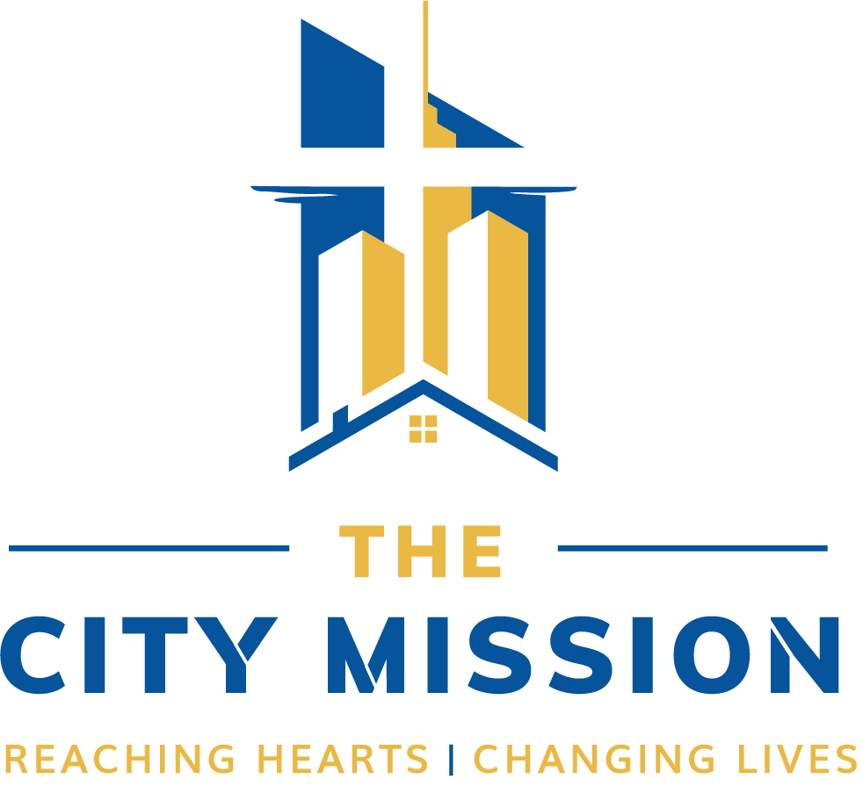

**VOLUNTEER HANDBOOK**

**VOLUNTEER HANDBOOK**

The City Mission welcomes you as a volunteer. Volunteers are viewed as valued partners, meaning that we seek quality volunteers with proven character, commitment, and competency. Volunteers selected will be placed in a wide range of duties, including spiritual ministry and leadership. Staff will accept, involve, supervise, and recognize the volunteers in their department. This also means that we will seek their input and consider their perspective in decision making. Involvement of volunteers allows us to reach many more in need, enables us to accomplish ministry at a reduced cost, and gives us the opportunity to train those joining us in the strategies that are being successfully applied to community needs.

**TABLE OF CONTENTS**

**Letter from our CEO Page 3**

**Who We Are Page 4**

**Volunteer Program Page 5**

**Why Volunteer Page 6**

**How to Become a Volunteer Page 6**

**Volunteer Behavior/Conduct Page 7**

**Social Media Policy Page 10**

**Grievances Page 11**

**Safety Statement Page 11**

**Individual Compliance Agreement Page 12**

**Group Compliance Agreement Page 12**

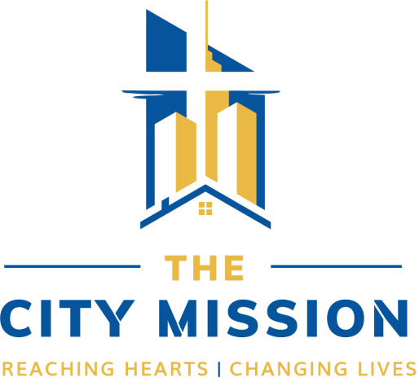

**WELCOME FROM OUR CHIEF EXECUTIVE OFFICER**

Dear Volunteer,

On behalf of The City Mission, I want to welcome you to our team. We are thrilled that the Lord has led you here and we trust that you will make a significant contribution to this ministry and that your involvement with The City Mission will be fulfilling.

We take seriously the ministry that the Lord has entrusted to us. We are committed to meeting the needs of our clients in accordance with our mission statement and goals. Most importantly, we desire to introduce men, women, boys, and girls to Jesus Christ so that they might enter into a life-changing personal relationship with Him. Further, we believe that each and every position within the Mission is an important part of ministry.

The following pages are very important and I encourage you to read them carefully. It is essential that all have knowledge of TCM policies so that as we labor together, each of us will have clarity of expectations and a spirit of unity. It is our goal that Jesus Christ is glorified in all things in this ministry and that we serve in faithful obedience.

In Christ,



**THE CITY MISSION**

The City Mission is a holistic ministry that exists to serve men, women, and children at their point of crisis by progressing them towards stability, employment, and independent housing. Our programs function to enable those at-risk, in crisis or incarcerated to live self-sufficient lives of faith, productivity, and excellence. This dynamic ministry provides essential community services such as adult education, vocational training, job readiness training, mental health counseling, youth programming, re-entry, Spiritual direction, and much more.

Through wars, depression, economic recession, and decades of change for the city of Cleveland, dedicated men and women worked hard and adapted to meet the changing needs of those experiencing crisis. We continue to follow their example today by providing **Help, Heart,** and **Home** in ways that are both effective in sustainability and sharing the love of Christ.

**MISSION STATEMENT**

Providing help and hope to all people through the transforming power of God's love.

**VISION STATEMENT**

The City Mission, known for faithfully proclaiming the gospel of Jesus Christ, will be a catalyst for positive change in Cleveland resulting in the radical transformation of individuals and communities for generations to come.

**CORE VALUES**

The values of The City Mission serve as the behavioral guidance system of the Mission. Organizational strategy, goals, actions and behavior will all be inspired by, evaluated against, and conformed to the values of The City Mission.

Directed by the **Bible**

Dedicated to **Transformation**

Bound by **Integrity**

Inspired by **Responsibility**

Energized by **Collaboration**

Strengthened by **Commitment**

**THE CITY MISSION’S VOLUNTEER DEPARTMENT**

The Volunteer Department oversees the enrollment of all volunteers, whether serving individually or as part of a family, church, organization, or business. The Volunteer Department approves all volunteers and helps in placing them throughout The City Mission’s programs and facilities.

General volunteer questions can be directed to our team:

* Email: getinvolved@thecitymission.org
* Volunteer Services Supervisor: Jaime Buxton
  + [jbuxton@thecitymission.org](mailto:jbuxton@thecitymission.org)
  + Phone: 216-431-3510 ext. 316

**The City Mission values our volunteers. We will endeavor to:**

* Treat you as a co-laborer in the ministry of the Mission
* Offer you suitable assignments
* Provide appropriate training and supervision
* Offer you information about new developments and opportunities
* Provide guidance and direction by experienced, informed, patient, and thoughtful staff
* Provide an orderly designated workplace
* Solicit your feedback and suggestions
* Give recognition and appreciation for your service

**Your Commitment to the Mission: as a vital and trusted volunteer, I will:**

* Be timely and reliable in the fulfillment of my duties
* Accept supervision graciously
* Conduct myself in a professional manner, with courtesy and consideration
* Speak and behave in a manner consistent with the faith and values of the Mission
* Hold in confidence any information gained about guests and clients at the Mission
* Be supportive of Mission staff and their decisions
* Take concerns or suggestions to my site supervisor or the volunteer manager
* Be flexible when changes are needed
* Treat everyone with respect, loyalty, patience, integrity, courtesy, dignity, and consideration
* Avoid situations where I am alone with children, youth, clients, and guests
* Use positive reinforcement when working with children, youth, clients, and guests
* Report suspected abuse to staff, administrator, or appropriate supervisor

**As a vital and trusted volunteer, I will not:**

* Use, possess, or be under the influence of alcohol while volunteering
* Use, possess, or be under the influence of illegal drugs at any time
* Volunteer when I am sick
* Strike, spank, shake, or slap children, youth, clients, or guests
* Humiliate, ridicule, threaten, or degrade children, youth, clients, or guests
* Touch a child, youth, client or guest in a sexual or other inappropriate manner
* Use discipline that frightens or humiliates children, youth, or clients, or guests
* Use profanity while volunteering at the Mission

**WHY VOLUNTEER**

**We are Called** – As a faith-based organization, the Mission believes that all individuals are called and gifted by God to serve one another. Matthew 20:28 says that “just as the Son of Man did not come to be served, but to serve…,” so we are called to serve. Volunteering is a practical, tangible way of being God’s hands and feet to a needy world and volunteers are needed to serve, rescue, and transform those in greatest need.

**Great Need** – There are great needs within our families, neighborhoods, communities and the region we serve. The Mission could not reach and impact as many people as we do without the wonderful support and partnerships we have with our volunteers.

**Fun and Rewarding** – It’s fun to serve. You meet new people, develop new relationships, and discover, grow, and use gifts and talents you may or may not know about!

**Obligation** – Sometimes we start serving as an obligation – for school, church, community service, or simply out of civic obligation. It’s perfectly fine to serve for this reason! Many volunteers start in this mode, but are transformed themselves and keep on going after their “obligation” is met.

**Better Health** – Volunteering means you’re active. Activity has long been linked to better overall physical health and well-being. New research suggests positive feelings translate to better mental health as well.

**Experience Transformation** – As a volunteer, you will get to see and experience transformation in the lives of children, youth, clients, guests, staff, volunteers and the communities we serve. Transformation through restored relationships with God, self, and others is an extraordinary thing to be a part of!

**DEFINITION OF A VOLUNTEER**

A volunteer is anyone who, without compensation or expectation of compensation beyond reimbursement, performs a task at the direction of and on behalf of The City Mission. A volunteer must be officially accepted and enrolled by The City Mission prior to performance of the task. Unless specifically stated, volunteers shall not be considered as employees of The City Mission.

**HOW TO BECOME A VOLUNTEER**

* Attend a Prospective Volunteer Introduction
* Please complete the online volunteer application. Your volunteer application will be reviewed and approved within 1-3 business days.
* Read and sign a Waiver and Volunteer Agreement
* Complete a Statement of Faith and Questionnaire
* Attend an onsite interview
* Participate in any other required trainings for department of service

**AGE REQUIREMENTS**

All volunteers must be ages 18 years or older and must complete the online volunteer application and be approved to serve.

Youth desiring to serve must volunteer with a parent/guardian or adult chaperone, but the adult will then be required to complete a volunteer application on their behalf. We encourage students to volunteer as we know that having an official volunteer record can help fulfill volunteer service requirements and/or expectations for schools, scholarships, job applications, etc.

**CRIMINAL BACKGROUND REVIEW**

The City Mission serves a substantial number of vulnerable populations, such as intimate partner violence victims, human trafficking victims, youth, etc. To help protect these populations, the volunteer application process includes a background review of criminal history.

Volunteer applicant with a criminal history is not necessarily or automatically excluded from volunteering. The City Mission considers a variety of factors, including, but not limited to the type of offense, frequency, magnitude, and timing of offenses.

We generally allow volunteers to serve in any program area or facility at the Mission. On occasion, we may, at our discretion, ask a volunteer to limit their service to a particular facility.

On rare occasions, volunteer applicants will not be allowed to serve—typically if they have recent or an extensive and on-going criminal history and/or record of sexual crimes.

Volunteer applicants are always offered the opportunity to explain their criminal history and their accompanying stories of redemption, restitution, corrective actions, etc. that may not be readily apparent in an initial criminal background check.

Additional questions or concerns about this process can be directed to the Volunteer Services Supervisor, Jaime Buxton: [jbuxton@thecitymission.org](mailto:jbuxton@thecitymission.org)

**PROGRAM GRADUATES VOLUNTEERING**

Current or recent program clients and guests should not normally volunteer until at least six months after program completion, to help ensure healthy boundaries and relationships are maintained between and amongst all current and former clients and guests.

Exceptions for current clients can be made, on a case-by-case basis for special events and activities, but such exceptions need to be approved through Volunteer Services Supervisor, Program Manager, and Case Manager in the respective program area where the event will occur.

**VOLUNTEERS WITH DISABILITIES**

In accordance with applicable regulations, we will work to make appropriate accommodations for persons with disabilities.

Please contact us directly at [getinvolved@thecitymission.org](mailto:getinvolved@thecitymission.org) so we can work with you to find the best fit for your accommodations.

**VOLUNTEER GROUPS**

Most sites and facilities of the Mission are set up to accommodate groups of 4-25 people; this constraint is an operational and safety consideration for volunteers, staff, clients, and guests.

Larger groups may be considered on a case-by-case basis, but generally, if your group is larger than twenty-five volunteers (including any chaperones), then we ask that your group be deployed into two or more smaller teams. This helps ensure effective service and ministry to our clients and guests and helps ensure volunteers have a meaningful and transformative experience as well.

Each group member must complete their own volunteer waiver, while the team leader will complete the online GROUP application on the team’s behalf.

We generally cannot accommodate large volunteer groups during the evenings (after dinner) and most holidays, when extra staff are not available to supervise volunteers.

**UNABLE TO ATTEND A SCHEDULED VOLUNTEER ACTIVITY/EVENT**

The City Mission relies on and plans activities and events based upon registered volunteers. Please make every effort to keep your volunteer commitments. However, we understand that changes—illness, car troubles, etc.—are sometimes unavoidable. If you are unable to volunteer as planned, please cancel your volunteer event at [jbuxton@thecitymission.org](mailto:jbuxton@thecitymission.org) and notify The City Mission staff in the facility/program area you were scheduled to serve.

**SUPERVISION**

Volunteers working on site at The City Mission will be supervised by paid staff and/or a lead volunteer. The supervisor should be available to answer questions and provide direction and support at all times. Supervision will include making the volunteer familiar with restrooms, drinking water/coffee, emergency exit routes, the volunteer's work area, work expectations, supplies, and any other applicable information and working guidelines.

**MEALS FOR VOLUNTEERS**

Meals are available daily at both campuses, and volunteers serving at one of those facilities during mealtime are welcome to eat for a cost of $2 per meal. Please alert the Volunteer Department if you interested in purchasing meals.

Special meal accommodations can be made for volunteer groups but must be planned for at least 10 days in advance.

**NON-HARASSMENT**

The City Mission seeks to maintain an environment free from all forms of harassment. Conduct that creates an intimidating, hostile, or offensive environment is not acceptable. Any such conduct can result in dismissal from the Mission.

If you believe you have been subjected to or witnessed any type of harassment while volunteering at the Mission, you are required to bring the matter to the immediate attention ofyour supervisor, the department head, or the Volunteer Services Supervisor. Harassment complaints are investigated promptly and appropriate action will be taken.

**NON-FRATERNIZATION**

We welcome volunteers to interact in a friendly, respectful, and courteous manner, but use caution when relating to program clients and guests. The City Mission recommends that you do not give out your last name, email, phone number, address or social media contact information. We also ask that you should not make plans with a client or guest to meet outside the Mission unless sufficient time has elapsed to develop a healthy relationship and approval from the case manager has been given.

**CONFIDENTIALITY**

Confidentiality can be a life and death issue for some people. The City Mission staff and volunteers are responsible for protecting the privacy of clients and guests at the Mission. No information about the Mission clients and guests is to be given verbally or in writing to anyone, including news agencies and social media.

**GIFTS TO CLIENTS**

Clients of The City Mission have most of their physical needs provided for within their program at the Mission. If a volunteer learns about a client’s unmet need, the most productive way to respond is to alert the client’s case manager to the need.

At no time should a volunteer give money or a gift directly to a client of The City Mission. Should you wish to give a gift, please give to your direct supervisor who will deliver the gift anonymously to fill the need of the individual.

**WORKING WITH CHILDREN**

For the protection of the volunteer and children, only volunteers that have been background checked and fingerprinted should be alone with a child at any time. If a need arises that requires an exception, permission from the volunteer's on-site supervisor is required.

**SMOKING, ALCOHOL, & DRUGS**

All facilities operated by The City Mission are non-smoking facilities, and alcohol and drug free zones.

**PERSONAL BELONGINGS**

Volunteers are responsible, at all times, for their personal belongings. We encourage you not to bring purses, wallets, cameras, unnecessary extra items (clothes, bags, etc.), money and other valuables when you come to serve. If something is missing, please report it to your supervisor.

**RESERVING THE RIGHT TO SERVE OR REMOVAL OF VOLUNTEERS**

The City Mission reserves the right to limit, remove or refuse a volunteer from serving at any Mission facility, program or event. This determination—made at the sole discretion of The City Mission staff—may be due to, but is not limited to such things as non-compliance with volunteer guidelines, not maintaining appropriate physical, emotional and relational boundaries, being a recent client or guest of the Mission, and angry, harassing, threatening, or disrespectful behavior and/or words directed towards staff, clients and guests, other volunteers, etc.

**SOCIAL MEDIA POLICY**

The City Mission believes that Social Media tools can be both positively and negatively powerful, therefore their impact on TCM and those we serve is of vital concern. We want the excitement and hope of what we do to be widely shared in the digital community, as it has been within the physical community for over a century. Because of these interests, we believe it is critical to safeguard our staff and our clients against potential dangers. We’ve set the following policies and guidelines for effective use of all social media platforms.

**Respect for Those We Serve**

Much is worth sharing at TCM! Should you choose to do so, consider the following to **ensure the trust and safety of our clients**:

* Unless it is impossible, always let the client, volunteer, sponsor, or donors know what you would like to share and get their approval before doing so.
* Unless you are referring to a public figure (i.e. sports figure, media personality, recognized community leader, etc.) or staff member, **mention first name only**.
* **If a parent is present, please ask them for permission to mention or use a picture of their child.** If the parent is not present, please double check with staff that the child will not be put at risk for harm with a shared photograph.
* **Public knowledge of their location can put some clients at risk** (especially at Laura's Home and Pathways). Be certain your post has taken all precautions before uploading.
* Avoid posting words or images that could cast our clients in a negative light, even in misinterpretation.
* Give your pictures and words a second look for mistakes and to consider how they could be misinterpreted to avoid embarrassment for you and TCM before sharing.

** There are always new situations and room for interpretation in areas that require personal judgment such as these. Please contact the Content Marketing Specialist at [Connect@TheCityMission.org](mailto:Connect@TheCityMission.org) if you have any questions or concerns.

**GRIEVANCES**

The volunteer department is available to hear grievances from volunteers. Volunteers submitting grievances will be first encouraged to interact directly with staff leading volunteers in the department to resolve their differences. If the grievance continues, the Volunteer Services Supervisor will serve as a neutral person to listen to both perspectives. We will only hear grievances that the volunteer is willing to express in the presence of the offending party. The direct supervisor of the paid staff involved will always be notified of a grievance and will be involved in any meetings that take place. The goal of hearing grievances is to resolve conflicts and restore relationships, not assign blame. If an appropriate resolution cannot be achieved, the volunteer may be encouraged to end their volunteer assignment rather than cause division. Also, paid staff may be referred to supervisory staff for appropriate discipline. Both paid staff and volunteers will be accorded the same fair, dignified, and equal treatment and access throughout the process.

**SAFETY STATEMENT**

The City Mission is committed to protecting our employees, volunteers, clients, and children whom we serve, as well as the public and our property. We take seriously our responsibility to conduct our business and to provide services in a manner that protects the safety and health of our employees and the people in our care.

All volunteers will be provided with care, first-aid and emergency service, as required, for injuries or illnesses while on TCM premises. Volunteers should contact their Supervisor, the nearest Supervisor, and/or 911 in the event of a serious accident or emergency.

If an injury is sustained while volunteering, it must be reported immediately or as soon as possible to the volunteer’s Supervisor, who in turn, will notify the Program Manager of the incident. As soon as is practically possible, but in no case later than 24 hours following injury or incident, volunteer and/or Supervisor/Department Managers are required to complete an Accident and Incident Report form documenting the circumstances surrounding the incident. You may obtain an Accident and Incident Report form from your Supervisor or the Security office.

**ANY MORE QUESTIONS?**

We have endeavored to cover all volunteer related questions in this handbook and through the Mission’s website, but you may still have more questions. If so, please feel free to contact us at [getinvolved@thecitymission.org](mailto:getinvolved@thecitymission.org) with further questions.

**VOLUNTEER HANDBOOK AGREEMENT**

**INDIVIDUAL COMPLIANCE AGREEMENT**

I, volunteer, confirm that I have read the Volunteer Handbook. I understand its terms. I have had the time and opportunity to read and ask questions regarding the Volunteer Handbook and this Agreement. I agree to abide by all rules and guidelines contained within them.

*\*Compliance agreement is signed electronically when volunteer submits The City Mission online volunteer application.*

**GROUP COMPLIANCE AGREEMENT**

As the designated group leader, I, volunteer, confirm that I have read the Volunteer Handbook. I understand its terms. I have had the time and opportunity to read and ask questions regarding the Volunteer Handbook and this Agreement. I agree to abide by all rules and guidelines contained within them. Furthermore, I agree to ensure my group has a thorough understanding of the Mission’s Volunteer policies. Also, I agree to provide the Volunteer Services Supervisor a list of my group member’s names, addresses, phone number, and email addresses (if needed) before beginning our volunteer assignment.

*\*Compliance agreement is signed electronically when volunteer submits The City Mission online volunteer application.*